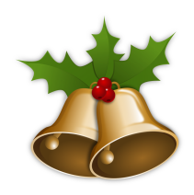
2018 Christmas Lunch
Novotel, Fishergate, York, YO10 4FD
Thursday 13rd December – 12 noon
MENU
Starters
SOUP Cream of roasted parsnip soup flavoured with truffle oil, garnished with chestnut crumbs and parsnip crisps

PRAWNS Traditional prawn cocktail. King prawns with avocado on baby gem lettuce, topped with Marie Rose sauce.

HAM HOCK Ham hock and apricot terrine. Locally sourced ham hock, pickled vegetables, pea shoots and apricot served with apple slaw
Main Courses
TURKEY Traditional roast turkey. A fresh turkey escalope rolled and stuffed with sage and onion, served with all the trimmings, finished with a rich onion gravy
HAKE Fillet of hake. A pan fried hake fillet on a bed of saffron potatoes, accompanied by tender stem broccoli and peas in a tarragon cream
NUT ROAST Nut roast Wellington. Butternut squash and chestnut mushrooms encased in flaky puff pasty with a roasted red pepper sauce
Desserts
CHRISTMAS PUDDING Spirit of Christmas. Traditional pudding with lashings of brandy sauce
CHOCOLATE PUDDING White and dark chocolate pudding. Served warm and perfectly finished with creamy vanilla ice cream
CHEESES Selection of local cheeses served with crackers, chutneys, fruit
and nuts

£15 per head for members, £21 for non members

